 Finding All of the Relevant Data Sets

Once you've chosen a topic, you'll want to pick an angle to investigate. It's important to choose an angle that has enough depth to analyze, but isn't so complicated that it's difficult to get started. You want to finish the project, and you want your results to be interesting to others.

One of the most controversial issues in the U.S. educational system is the efficacy of standardized tests, and whether they're unfair to certain groups. Given our prior knowledge of this topic, investigating the correlations between [SAT scores](https://en.wikipedia.org/wiki/SAT) and demographics might be an interesting angle to take. We could correlate SAT scores with factors like race, gender, income, and more.

The SAT, or Scholastic Aptitude Test, is an exam that U.S. high school students take before applying to college. Colleges take the test scores into account when deciding who to admit, so it's fairly important to perform well on it.

The test consists of three sections, each of which has 800 possible points. The combined score is out of 2,400 possible points (while this number has changed a few times, the data set for our project is based on 2,400 total points). Organizations often rank high schools by their average SAT scores. The scores are also considered a measure of overall school district quality.

New York City makes its [data on high school SAT scores](https://data.cityofnewyork.us/Education/SAT-Results/f9bf-2cp4) available online, as well as the [demographics for each high school](https://data.cityofnewyork.us/Education/DOE-High-School-Directory-2014-2015/n3p6-zve2). The first few rows of the SAT data look like this:

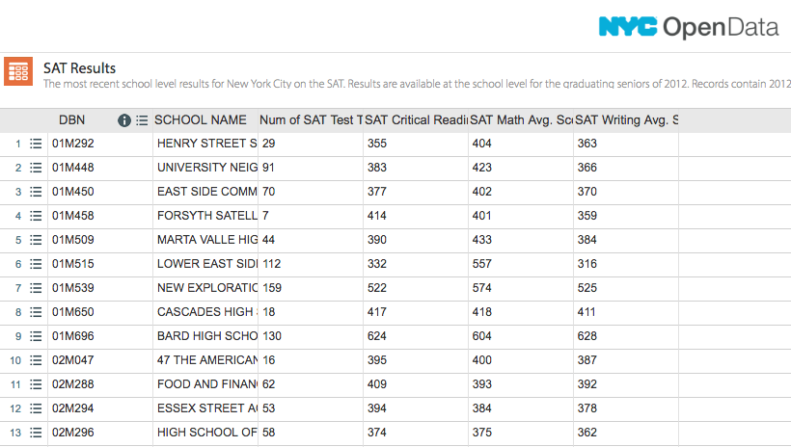

Unfortunately, combining both of the data sets won't give us all of the demographic information we want to use. We'll need to supplement our data with other sources to do our full analysis.

The same website has several related data sets covering demographic information and test scores. Here are the links to all of the data sets we'll be using:

* [SAT scores by school](https://data.cityofnewyork.us/Education/SAT-Results/f9bf-2cp4) - SAT scores for each high school in New York City
* [School attendance](https://data.cityofnewyork.us/Education/School-Attendance-and-Enrollment-Statistics-by-Dis/7z8d-msnt) - Attendance information for each school in New York City
* [Class size](https://data.cityofnewyork.us/Education/2010-2011-Class-Size-School-level-detail/urz7-pzb3) - Information on class size for each school
* [AP test results](https://data.cityofnewyork.us/Education/AP-College-Board-2010-School-Level-Results/itfs-ms3e) - Advanced Placement (AP) exam results for each high school (passing an optional AP exam in a particular subject can earn a student college credit in that subject)
* [Graduation outcomes](https://data.cityofnewyork.us/Education/Graduation-Outcomes-Classes-Of-2005-2010-School-Le/vh2h-md7a) - The percentage of students who graduated, and other outcome information
* [Demographics](https://data.cityofnewyork.us/Education/School-Demographics-and-Accountability-Snapshot-20/ihfw-zy9j) - Demographic information for each school
* [School survey](https://data.cityofnewyork.us/Education/NYC-School-Survey-2011/mnz3-dyi8) - Surveys of parents, teachers, and students at each school

All of these data sets are interrelated. We'll need to combine them into a single data set before we can find correlations.